# Name: ________________________________________________________ Date: ______________

# Measurements Around the Classroom

**Purpose**: In this lab session, you will learn how to use instruments to make quantitative observations. The instruments you will use today are the triple beam balance, the electronic balance, the graduated cylinder, pipet, meter stick, 30 cm ruler, and a thermometer.

**Equipment and Materials Needed:**

Triple beam balance, electronic balance, graduated cylinder, tap water, distilled water, pipet, meter stick, ruler, measuring tape, thermometer, and beaker.

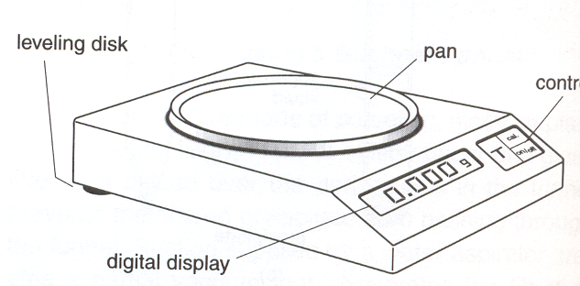**Station 1: Using a Balance**

A balance is an instrument used to measure the mass of a substance. Mass is defined as the quantity of matter (atoms) in an object. Matter is everything that is around you, without atoms there would be no matter! In general, the heavier the object the higher the object’s mass. An object’s mass is determined when it is placed on a balance and then compared to a known mass. The base unit of mass in the SI system is the kilogram. Most balances in chemistry labs use grams as the unit given.

**MAJOR RULES for the Electronic Balance:**

* Do not push down on the balance with your hand. For some reason, students love to do this and then we don’t have a balance to use in class.
* Never exceed the mass of the balance by putting too much weight. Always check to see what the maximum weight of the balance before attempting to use it.

**Electronic Balance PROCEDURE:**

1. Turn on the electronic balance. Allow it to zero itself.
2. Take an aluminum can and place it directly on the balance. Allow it to come to equilibrium. Now record the mass of the can in the space below. *Remember your units!!*

Mass of Aluminum Can (using the electronic balance): _____________________

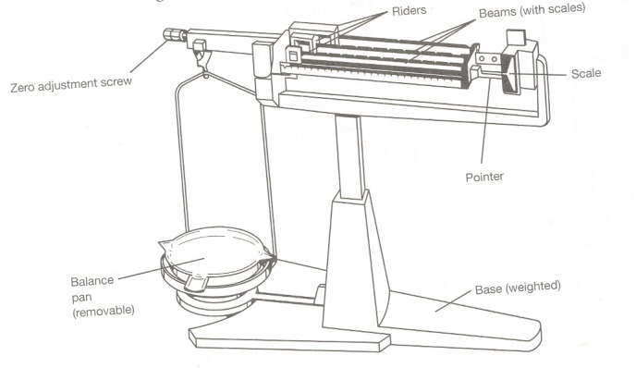

**RULES for using a Triple-Beam Balance:**

1. When transporting a balance to your lab station, always use 2 hands to transport the balance. Take care not to bang it against anything as you move it.
2. Check the balance before you start. The balance pan should be empty and clean, and all masses should be set on zero. The balance must be level. Check that the lines meet up on your balance. If not, try to zero the balance by lining them up.
3. Objects to be placed directly on the balance pan must be clean, dry, and at room temperature.

**Triple Beam Balance PROCEDURE:**

1. Place the aluminum can directly on the balance. Move the riders until it is balanced. Record the mass of the aluminum. You should have 3 decimal places in your final answer.

Mass of Aluminum Can (using triple beam balance): ___________________________ (don’t forget your units)

1. Place any object on the balance other than the can. Use a penny, eraser, pen, or something else. Move the riders until balanced. Record the mass of the object.

Mass of object (using triple beam balance): __________________________

1. Now place the aluminum can on the balance pan along with the object. Move the riders again and obtain the combined mass.

Mass of object + aluminum can (using triple beam balance): ____________________________

1. To determine the mass of the can, you have to find the difference in the two measurements above. Show work below. Place your final answer in the space provided.

Step 3 – Step 2 = Mass of the Aluminum Can: _________________________________

Did you get a different mass for the aluminum can? __________________________

Which mass is closest to the mass of the aluminum can using the electronic balance (mass determined in step 1 or the mass determined in step 4)?

**Station 2: Graduated Cylinder**



Volume is the amount of space a sample of matter takes up. Volumetric glassware, unlike other glassware, is calibrated with markings that are used to determine the specific volume of liquid in the volumetric glassware.

A liquid in a plastic tube will lie flat, but a liquid in a glass tube has a curved surface known as a **meniscus**. In most cases, the meniscus is concave and the bottom of the curve is read to determine the volume of a liquid. When reading the volume, always looks straight on to find the bottom of the meniscus. See figure to the right.

**PROCEDURE:**

1. Pour approximately 6 mL of tap water into a beaker using the sink.
2. Now determine how accurate you were by pouring the water from the beaker into a 10 mL graduated cylinder. Read the bottom of the meniscus to determine the volume of water you added. Record the volume of the water using the correct precision by estimating one decimal place past what is shown on the graduated cylinder. *You should have two (2) decimal places in your answer!*

Volume of water:___________________ (don’t forget your units)

What is more accurate? Measuring 6 mL of water using a beaker or a graduated cylinder?

**Measuring volume by displacement:**

You have an irregularly shaped object (a rubber stopper) and you would like to know the volume of it. You can do this through displacement. To do this:

1. Use a graduated cylinder that has a larger opening than the size of the object.
2. Fill the graduated cylinder ½ full of tap water. Record the starting volume of water in the cylinder.

Volume of Water (in cylinder): ___________________

1. Tilt the graduated cylinder and slowly slide the object into the water. Be careful not to splash.
2. Record the volume of the water + object.

Volume of Water + Object: ____________________

1. To determine the volume of the object, all you have to do is subtract the 2 pieces of data collected. Show work!

Step 4 – Step 2 = Volume of Stopper: _____________________ (remember units!)

**Station 3: Length**

1. Using a metric ruler: Record the length of your right index finger’s 2nd digit. Record the length in millimeters. (You should have 2 decimal places in your answer.)

Length of 2nd digit of right index finger: ____________________(don’t forget units)

1. Using a meter stick determine your height in centimeters. Convert your height in meters. SHOW the conversion.

Height (cm):___________________________ Height (m): __________________________

**Station 4: Temperature**

Now you will be trying your skills at estimating temperature. You will also learn to read a thermometer properly. In science, temperature is usually measured and recorded in degrees Celsius (oC). However, you are probably more familiar with the Fahrenheit scale (oF).

1. Fill a beaker approximately half way with warm tap water. Touch the water with your fingers. Make an estimate of the temperature in oC knowing that room temperature, usually about 72oF, is equal to 25oC.

Estimate of Temperature (oC): __________________________

1. Get a thermometer. How many oC are represented between the closest two marks on the thermometer’s scale?

__________________________

1. To what decimal place can the thermometer be estimated? __________________________
2. Place the thermometer in the water. Leave it immersed until the temperature stabilizes. What is the actual temperature of the water?

Temperature of Water (using thermometer): ___________________________ (remember UNITS!)

1. Was your estimated temperature close to the actual, measured temperature?

**Station 5: Practice Problems**

**QUESTIONS: Reading Instruments to the correct number of significant figures.**

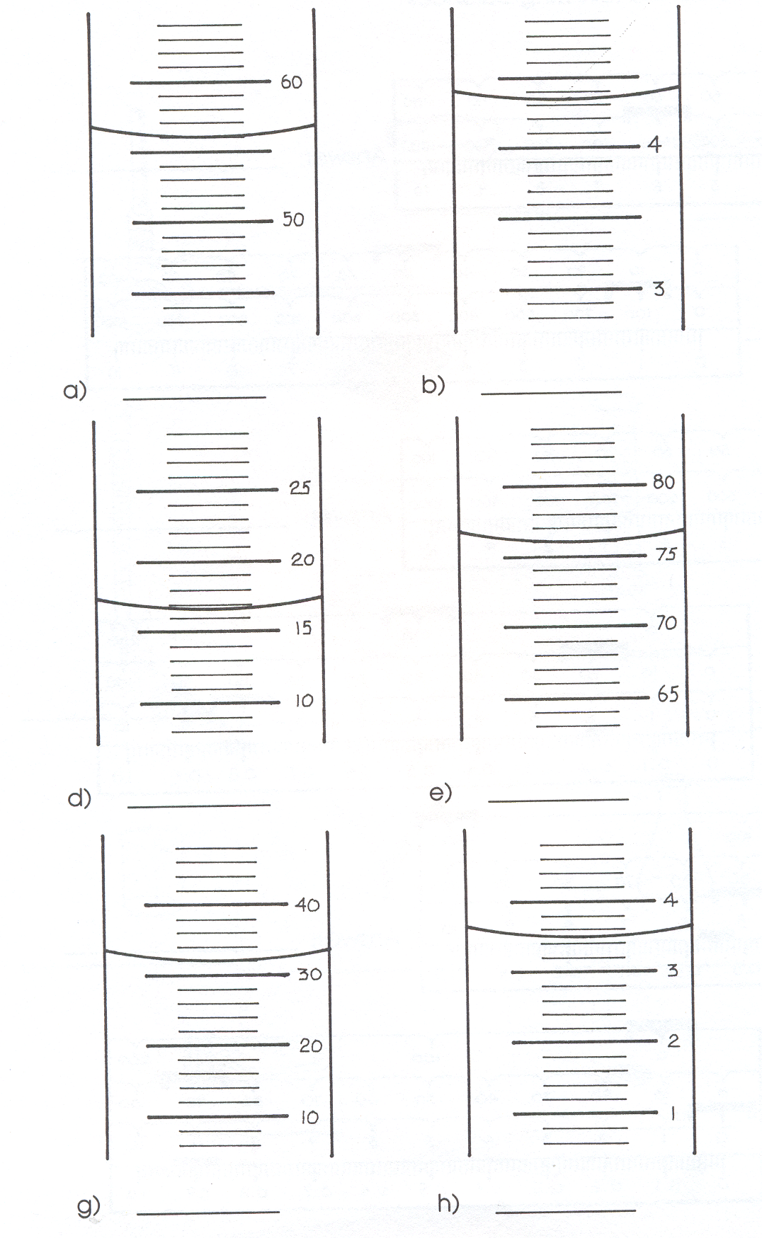

When reading instruments, you need to record the reading to the correct number of significant figures. What this means is that you are to record your answers so that you record all numbers you are sure of in the measurement, plus you are allowed one guess. If the measurement appears to be on a line, then the last figure written should be a zero.

1. To the right are sections of graduated cylinders with water in them. The units for all of the measurements are milliliters.

2. Read each graduated cylinder and record the measurement to the correct number of significant figures. Always state the figures you are sure of, plus one guess (for in between lines).

3. Make sure you record your measurements using the proper units.

4. Each of the graduated cylinders may be different from each other.

**Reading a balance:** Below are 2 different types of balances. Record the mass for each balance to the proper number of significant figures. Make sure you use grams for your units.

