Name: _________________________________________ Period: _____ Date: _________________

Significant Figures
Note Sheet
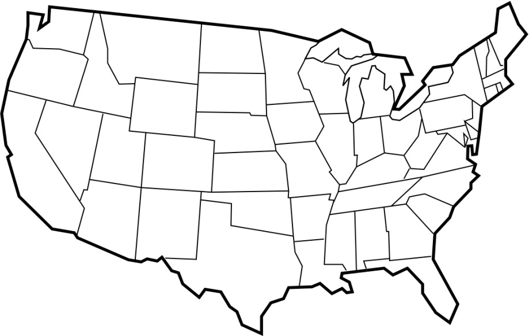

Atlantic
Pacific

Pacific – “P” stands for decimal point is present (actually written). If the decimal point is present, count significant digits starting with the first non-zero digit on the Pacific side (left).

Examples:
- 0.004713 _______ | - 18.00 _______ | - 1.20 _______
- 0.85 _______ | - 0.0962 _______ | - 12.95 _______

Atlantic – “A” stands for decimal point is absent (not written). If there is no decimal point, start counting significant digits with the first non-zero digit on the Atlantic side (right).

Examples:
- 140,000 _______ | - 5278 _______ | - 120 _______
- 20060 _______ | - 1009 _______ | - 86100 _______

